- Sequence diagram for Order Price Calculation:

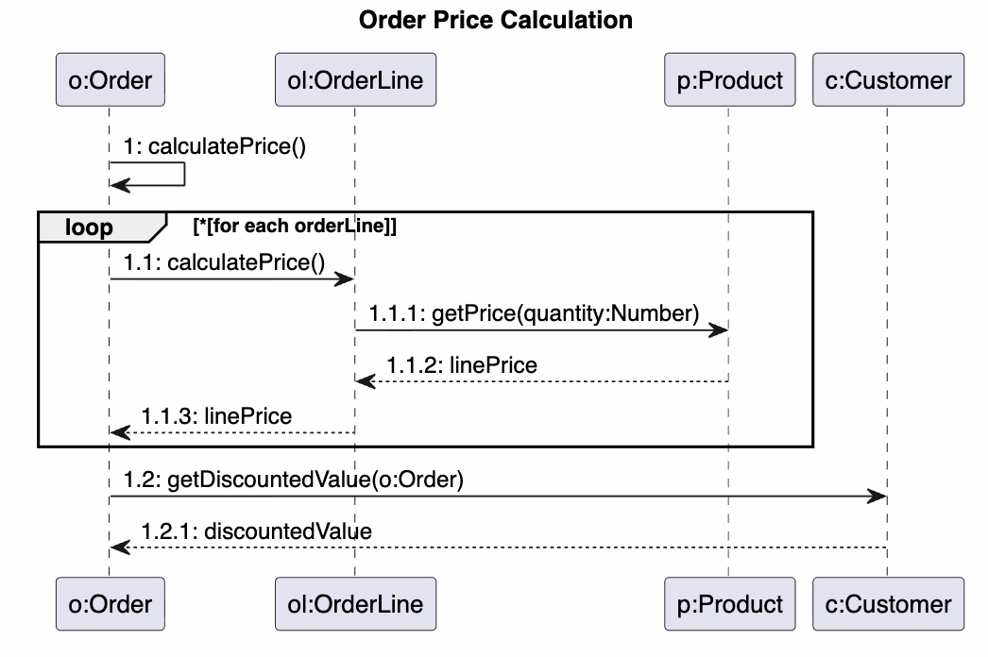

- Sequence diagram for Checkout Book
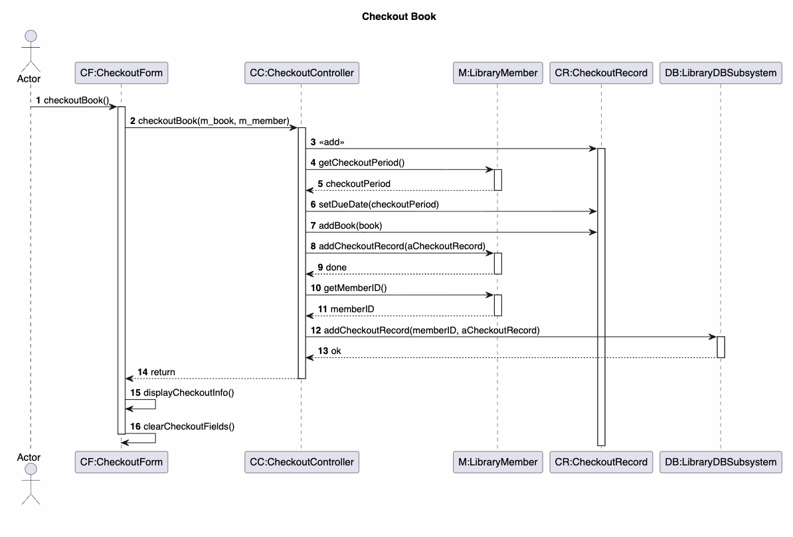

- Source code: https://github.com/miunthphuong/MPP/tree/main/Assigment/Lab4/code/Prob%20C/src
- S

